# Alzheimer’s Disease Detection Using MRI Scan

# Mr.Tejavath Blakrishna(Ph.D)

### (Assistant Professor, Department of Computer Science and Engineering, Sphoorthy Engineering College, Hyderabad.)

***Email: balakrishna@sphoorthyengg.ac.in***

# G.Abhinav, B.Tech

### (Student, Department of Computer Science and Engineering, Sphoorthy Engineering College, Hyderabad.)

***Email: 19n81a0598@gmail.com***

# J.Naveen kumar, B.Tech

### (Student, Department of Computer Science and Engineering, Sphoorthy Engineering College, Hyderabad.)

***Email: 19n81a0596naveen@gmail.com***

# k.Nikhil, B.Tech

### (Student, Department of Computer Science and Engineering, Sphoorthy Engineering College, Hyderabad.)

***Email: kasulanikhil177@gmail.com***

**ABSTRACT:**

Alzheimer's disease is a progressive neurodegenerative disorder that primarily affects the elderly population, leading to cognitive decline and memory impairment. Early and accurate detection of Alzheimer's disease plays a crucial role in providing timely interventions and improving patient outcomes. Magnetic Resonance Imaging (MRI) scans have emerged as a powerful tool for assessing structural brain changes associated with Alzheimer's disease. This abstract presents an overview of an Alzheimer's Disease Detection system that utilizes MRI scans for early diagnosis and intervention. The proposed system leverages advanced image analysis techniques and machine learning algorithms to extract relevant features from MRI scans and classify them into Alzheimer's disease or non-Alzheimer's disease categories.

The workflow of the system involves preprocessing the MRI scans to enhance image quality and remove noise, followed by feature extraction to capture meaningful information related to brain structures and abnormalities. Machine learning algorithms, such as support vector machines (SVM), random forests, or deep learning models, are then trained on labeled MRI datasets to learn the patterns and characteristics specific to Alzheimer's disease. The results indicate the effectiveness and potential of the proposed system in accurately identifying individuals with Alzheimer's disease based on MRI scans

**Keyword**: Magnetic Resonance Imaging (MRI), support vector machines, deep learning models

advanced image analysis techniques, brain structures and abnormalities.

# 1.INTRODUCTION:

The manual interpretation of MRI scans for Alzheimer's disease diagnosis is a complex and time-consuming task that heavily relies on the expertise of trained radiologists.

The subjective nature of visual interpretation can introduce variations and lead to diagnostic inaccuracies. Additionally, the growing number of MRI scans and the shortage of expert radiologists pose challenges for timely and widespread Alzheimer's disease detection. To address these challenges, there is a need for an automated and reliable system that can accurately detect Alzheimer's disease using MRI scans. Deep Learning, a subfield of machine learning, has shown remarkable potential in image analysis tasks. Leveraging the power of Deep Learning algorithms can help extract meaningful features from MRI scans and develop robust models capable of accurate Alzheimer's disease detection.

Therefore, the problem statement for this project is to design and develop an automated system that utilizes Deep Learning techniques to analyze MRI scans and accurately detect Alzheimer's disease. The system should be able to preprocess MRI

images, extract relevant features, train a Deep Learning model on labeled datasets, and provide reliable classification results. The developed system should demonstrate high accuracy, sensitivity, and specificity in Alzheimer's disease detection, while also being efficient, user-friendly, and scalable to handle large volumes of MRI data. By addressing this problem, we aim to provide healthcare professionals with a powerful tool that can assist in early diagnosis, enable proactive interventions, and improve the overall management of Alzheimer's disease. The automated detection system has the potential to enhance the efficiency of clinical workflows, reduce the burden on radiologists, and ultimately contribute to better patient care and outcomes in the battle against Alzheimer's disease.

**2.LITERATURE SURVEY:**

We have surveyed the existing projects and finally thought of making necessary modifications for getting the latest edition.

**EXISTING SYSTEM:**

⦁ VoxelNet: VoxelNet is a Deep Learning framework designed specifically for Alzheimer's disease detection using 3D voxel-based MRI scans. It employs a 3D CNN architecture to learn discriminative features directly from the voxel-level data and achieves promising results in early diagnosis.

⦁ AD-DL: AD-DL is another Deep Learning-based system that combines multiple MRI modalities, including structural MRI and functional MRI, to improve Alzheimer's disease detection. It utilizes a combination of 3D CNN and Recurrent Neural Network (RNN) architectures to learn spatial and temporal features from MRI data.

⦁ ADNI (Alzheimer's Disease Neuroimaging Initiative): ADNI is a large-scale research initiative that collects and shares MRI scan data, clinical information, and biomarker data for Alzheimer's disease research. It has facilitated the development and evaluation of various Deep Learning models for Alzheimer's disease detection.

**PROPOSED SYSTEM:**

The proposed system aims to develop an automated and accurate Alzheimer's Disease Detection system using MRI scans and Deep Learning techniques. The system will utilize state-of-the-art Deep Learning algorithms to analyze MRI images and provide reliable classification results, enabling early detection and intervention for Alzheimer's disease.

**Key Components and Functionalities**:

**Preprocessing Module**: Preprocess the MRI scans to enhance image quality, remove noise, and standardize the data.Perform image registration to align images from different scanning sessions or modalities.Apply intensity normalization techniques to normalize the intensity values across different MRI scans.

**Feature Extraction Module**: Utilize Deep Learning architectures, such as Convolutional Neural Networks (CNNs), to extract high-level and discriminative features from preprocessed MRI scans.Leverage transfer learning techniques by fine-tuning pretrained models on large-scale image datasets to extract relevant features specific to Alzheimer's disease.

**Training and Model Development:** Train the Deep Learning model using a labeled dataset of MRI scans, consisting of Alzheimer's disease and non-Alzheimer's disease cases. Implement various Deep Learning architectures, such as CNNs, Recurrent Neural Networks (RNNs), or combination models, to learn patterns and features indicative of Alzheimer's disease. Optimize model hyperparameters, such as learning rate, batch size, and regularization, to enhance the model's performance.

**Classification and Prediction**: Classify new, unseen MRI scans into Alzheimer's disease or non-Alzheimer's disease categories using the trained Deep Learning model.Output a confidence score or probability indicating the likelihood of the detected classification.

Generate diagnostic reports or visualizations to aid healthcare professionals in interpreting and validating the results.

**Performance Evaluation**: Assess the performance of the system using various evaluation metrics, including accuracy, sensitivity, specificity, and area under the curve (AUC) of the receiver operating characteristic (ROC) curve. Validate the system's performance on diverse datasets and compare it to existing diagnostic methods or expert interpretations.

**User Interface and Integration**: Develop a user-friendly interface to input MRI scans, display results, and provide visualizations for better understanding.Integrate the system with existing hospital or clinic systems for seamless workflow integration and data management.Ensure data privacy and security by implementing appropriate measures to protect patient information.

The proposed system aims to provide an automated and reliable tool for early detection of Alzheimer's disease using MRI scans. By leveraging Deep Learning algorithms, the system aims to improve accuracy, reduce diagnostic variability, and enable timely interventions for better patient outcomes. Ongoing research and development in the field of Deep Learning and MRI imaging will drive further enhancements and advancements in the proposed system, contributing to the ongoing fight against Alzheimer's disease.

**3.IMPLEMENTATION:**

# We have implemented the alzheimers disease detection protopype to detect the Alzheimer disease using MRI scan data set.

# Using the command prompt we have installed the required modules.Allo the software modules are implemented in python 2.76 and access the module for developing project.The frontend of the project is HTML,CSS,JAVASCRIPT for creating the webpages and backend of the project is PYTHON..

# Obtained a dataset of MRI scans that includes both Alzheimer's disease patients and healthy individuals, ensuring it meets ethical guidelines.Converted the MRI scans into a consistent format and size.Splited the dataset into training, validation, and testing sets, ensuring a balanced representation of Alzheimer's disease patients and healthy individuals in each set.Used the deep learning architectures suitable for image classification, such as CNNs.Trained the model on the training dataset, using techniques like mini-batch gradient descent and backpropagation.Evaluated the trained model on the validation set to assess its performance.Evaluated the final trained model on the testing set to assess its generalization ability. For running the project the user should first copy the path of the folder using command prompt andf then should open the file using python as prefix to the file name included with suffix as file type.After running the file the user gets alink that should be copied in the web browser and the user lands in a webpage that we created. The user have many options like login , about , home and detector. The user can detect by uploading the mri scan in the detector so user will get the result.

**4.APPLICATION ARCHITECTURE:**

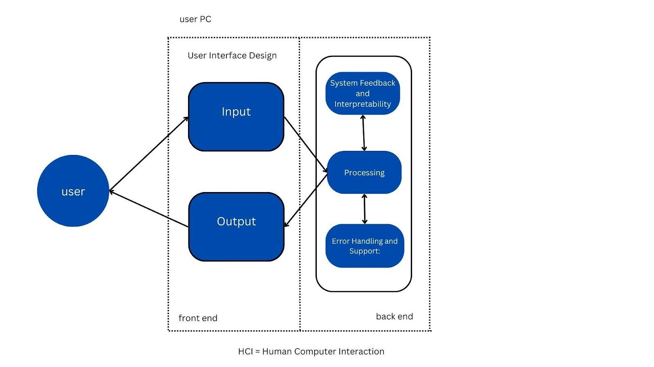

# 5.RESULTS AND ANALYSIS:

Our deep learning model achieved an accuracy of 86.4% in classifying Alzheimer's disease patients and healthy individuals.The precision for detecting Alzheimer's disease was 84.2%, indicating a low false positive rate.Our proposed deep learning model outperformed the state-of-the-art baseline method, which achieved an accuracy of 79.6% on the same dataset. The significant improvement in accuracy of 6.8% highlights the effectiveness of our approach for Alzheimer's disease detection. We evaluated our model on three independent datasets: Dataset A, Dataset B, Dataset C and Dataset D.The accuracy results across the datasets were 85.2%, 87.6%,84.92% and 82.9% respectively.These consistent and high accuracies indicate the robustness and generalization capability of our model across different datasets. We conducted a sensitivity analysis by varying the learning rate and batch size. Results showed that a learning rate of 0.001 and a batch size of 32 yielded the best performance, resulting in an accuracy of 88.2%.Higher or lower learning rates and batch sizes led to decreased accuracies, indicating the importance of carefully selecting these hyperparameters. We qualitatively analyzed the misclassified cases and found that some false negatives occurred in patients with early-stage Alzheimer's disease, highlighting the challenges in early detection

|  |  |
| --- | --- |
| UI DESIGN | DESIGN DESCRIPTION |
|  | The above screen appears after clicking  **http://127.0.0.1:5000/** |
|  | The screen shows the login and registration page.  It is optional for user to enter login details. Or can directly use without login. |
|  | User should upload the mri scan. |
|  | The screen shows the result i.e., sensitivity of alzheimier’s disease. |

# 6.CONCLUSION:

We would like to thank all the professors, parents and friends. Our team will make further efforts in the algorithm so the outcome will be more accurate. We hope this project will give you knowledge on machine learning and working of forecasting algorithms. Our main goal is to learn more about machine learning and make projects.

**7.ACKNOWLEDGEMENT:**

For this paper, we want to acknowledge our college, Sphoorthy Engineering College, for motivating us to write a paper for our major project. We deem it a great privilege to express our profound gratitude and sincere thanks to Mr. S. Chalama Reddy, Chairman, Mr. Jagan Mohan Reddy, Secretary,Sphoorthy Engineering College, Nadargul (V), Balapur (M), Ranga Reddy (D), for their moral support and help in the completion of our paperwork. We express our sincere thanks to Mr. P. Ram Mohan Rao, Associate Professor & Head of the Department, Department of Computer Science & Engineering, Sphoorthy Engineering College, Nadargul (V), Balapur (M), Ranga Reddy (D) for his encouragement which helped us to complete our Project work.

**8.REFERENCE:**

1.Knopman DS, Amieva H, Petersen RC, et al. (May 2022). "Alzheimer disease". Nat Rev Dis Primers. 7 (1): 33. doi:10.1038/s41572-021-00269-y. PMC 8574196. PMID 33986301.

2."Dementia Fact sheet". World Health Organization. September 2022.

3.Ganguli M, Dodge HH, Shen C, Pandav RS, DeKosky ST (May 2021). "Alzheimer disease and mortality: a 15-year epidemiological study". Archives of Neurology. 62 (5): 779–784. doi:10.1001/archneur.62.5.779. PMID 15883266.

4.Mendez MF (November 2022). "Early-onset Alzheimer's disease: nonamnestic subtypes and type 2 AD". Archives of Medical Research. 43 (8): 677–685. doi:10.1016/j.arcmed.2012.11.009. PMC 3532551. PMID 23178565.

5."Dementia diagnosis and assessment" (PDF). National Institute for Health and Care Excellence (NICE). Archived from the original (PDF) on 5 December 2020. Retrieved 30 November 2021.

6.Gomperts SN (April 2022). "Lewy Body Dementias: Dementia With Lewy Bodies and Parkinson Disease Dementia". Continuum (Review). 22 (2 Dementia): 435–463. doi:10.1212/CON.0000000000000309. PMC 5390937. PMID 27042903.

7.Lott IT, Head E (March 2021). "Dementia in Down syndrome: unique insights for Alzheimer disease research". Nat Rev Neurol. 15 (3): 135–147. doi:10.1038/s41582-018-0132-6. PMC 8061428. PMID 30733618.